01_D12B_SANJANA ASRANI_DWM EXP-02

GROUP-01

RETAIL STORE MANAGEMENT

**STAR SCHEMA**

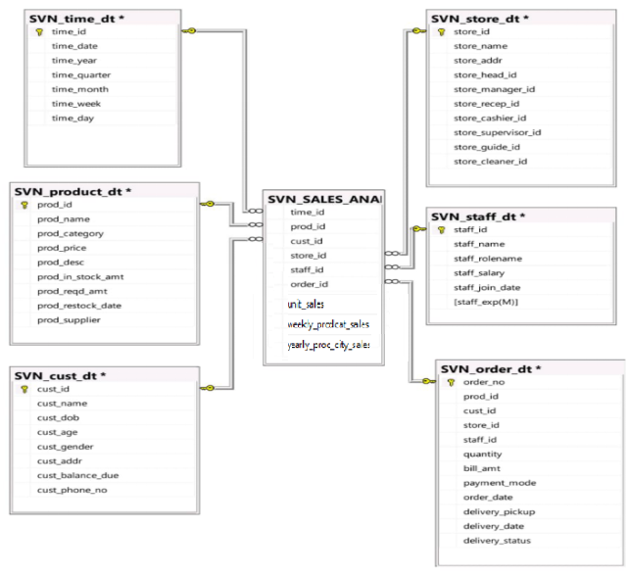

**SNOWFLAKE SCHEMA**

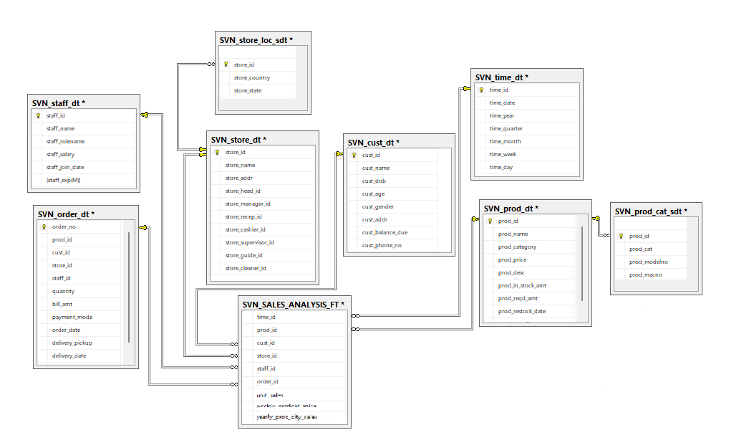

**INSERTING VALUES IN ALL TABLES :**

**SVN_PROD_DT**

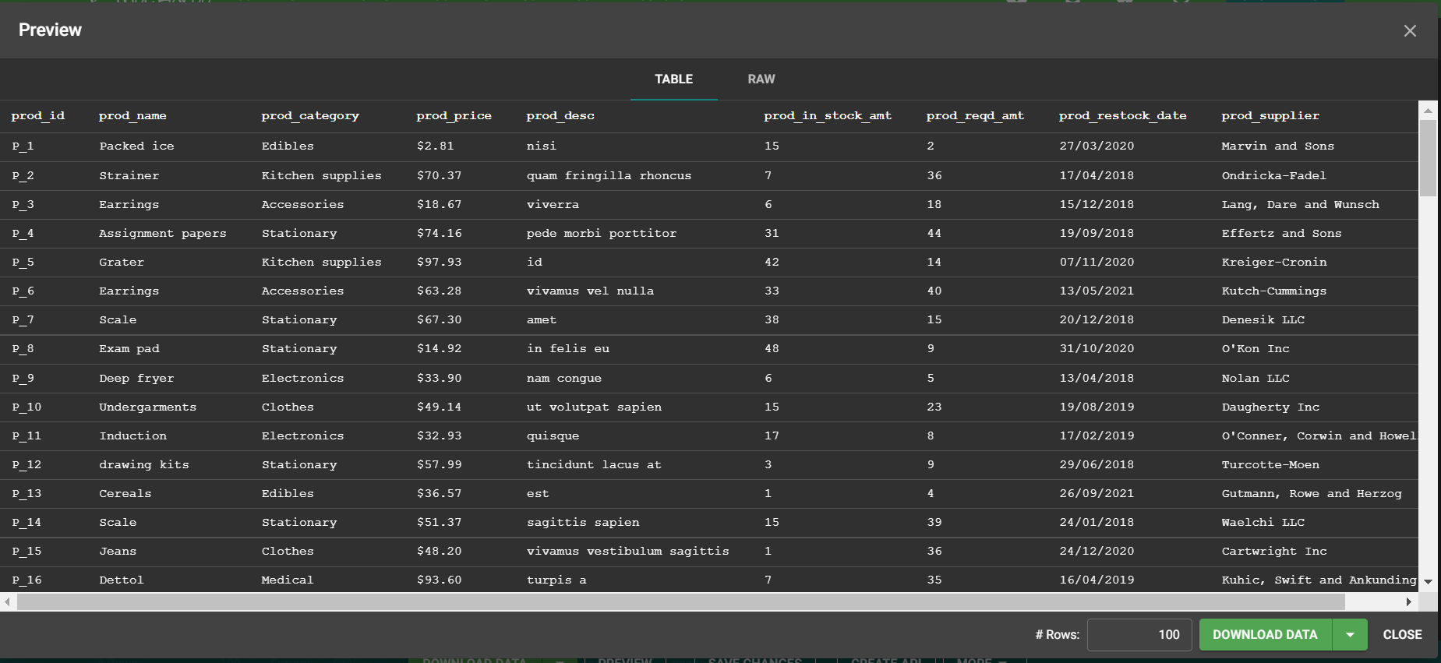

**SVN_CUST_DT**

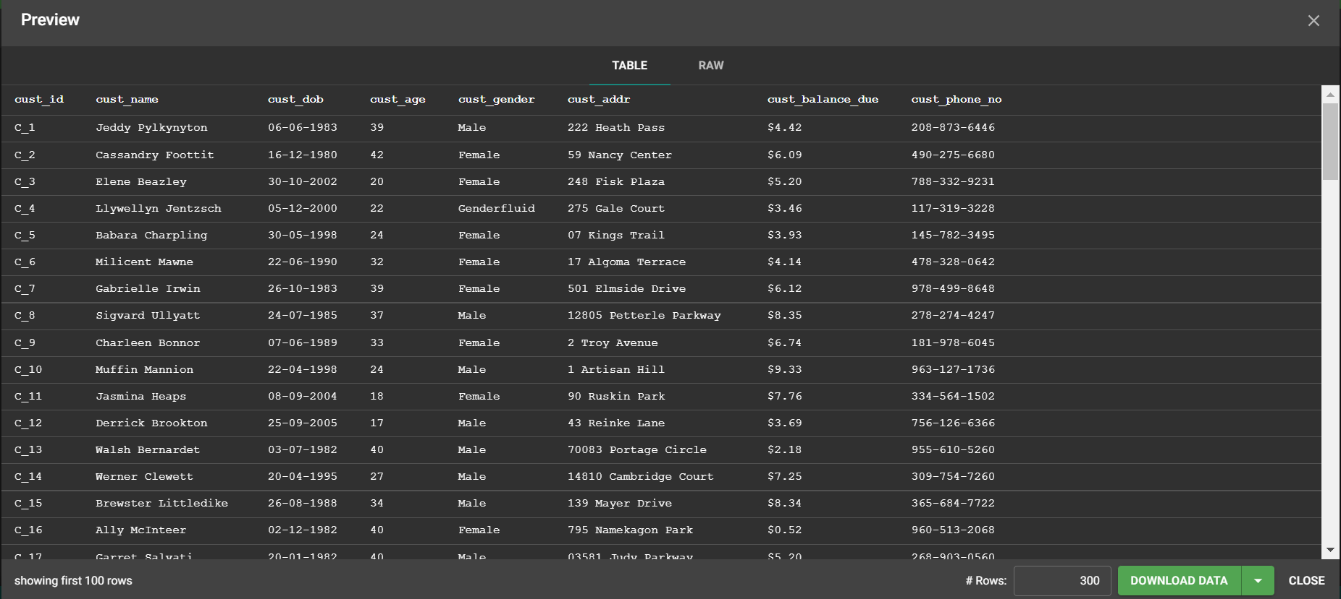

**SVN_STAFF_DT**

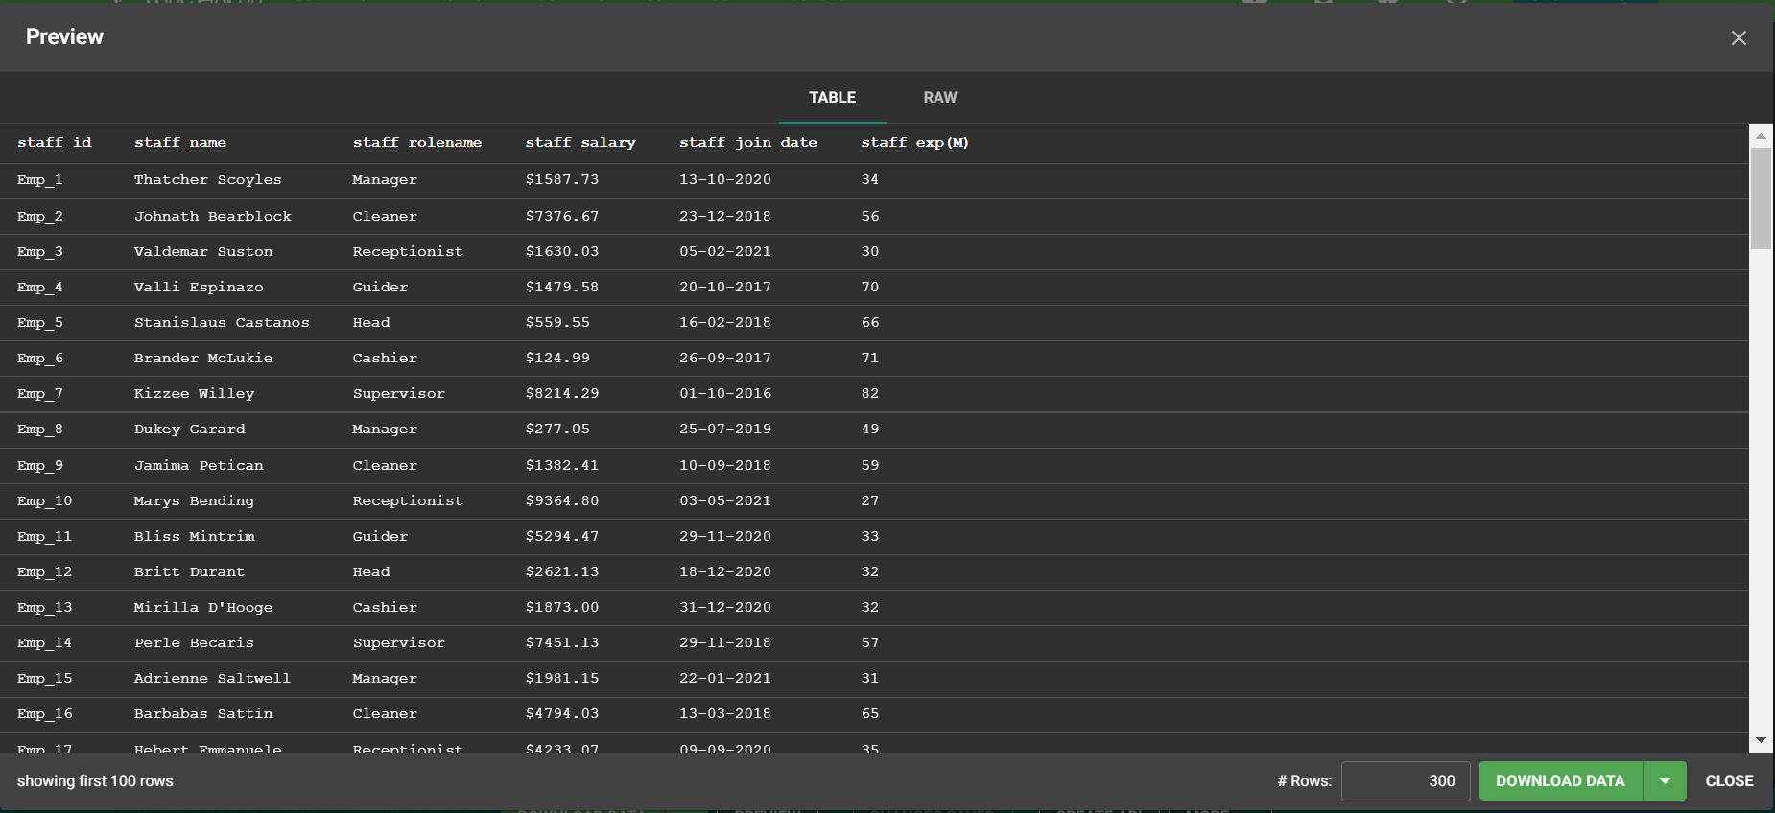

**SVN_STORE_DT**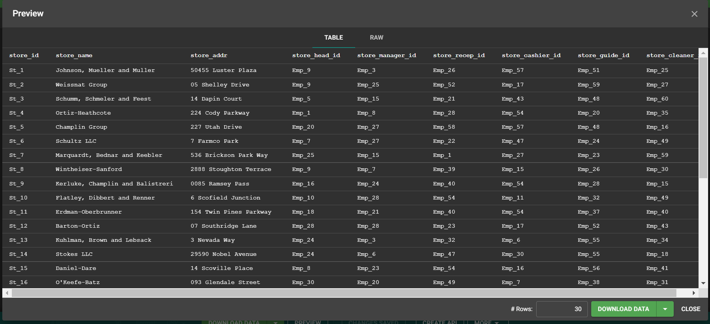

**SVN-ORDER_DT**

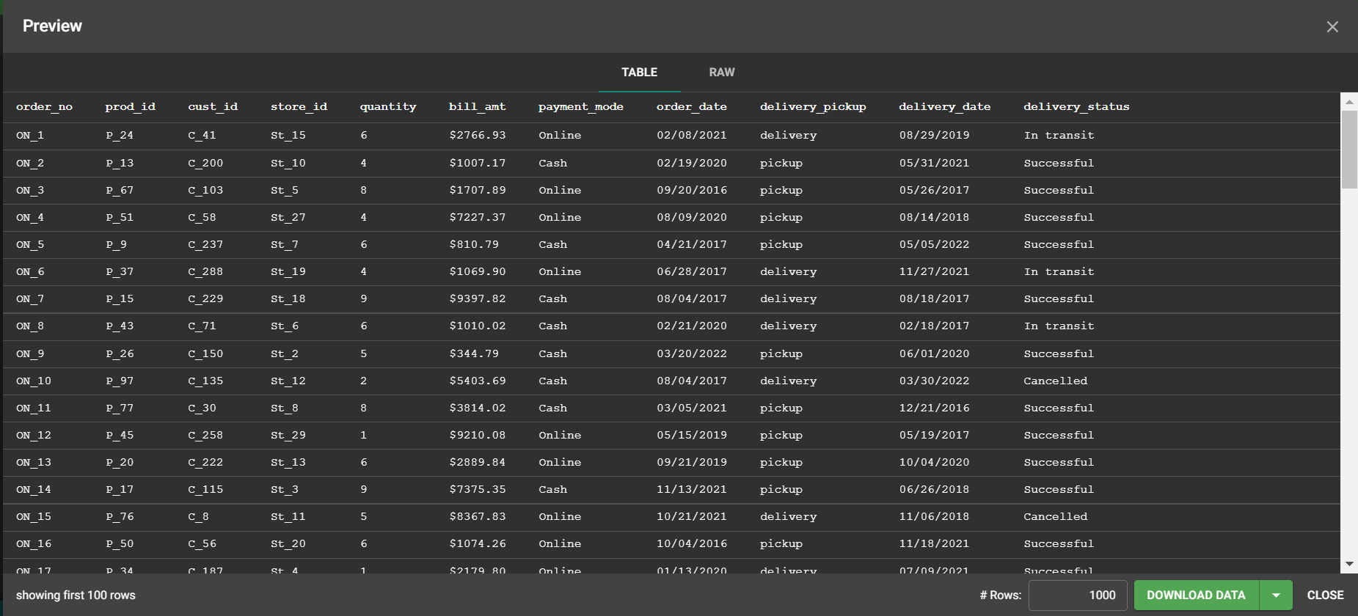

SCRIPT TABLE AS

**SVN_PROD_DT**

1. CREATE TO

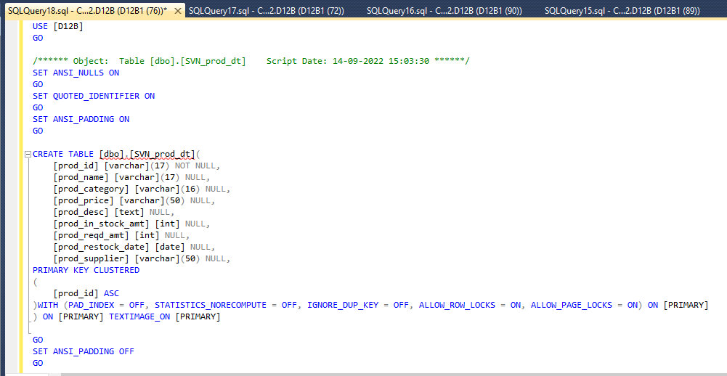

2. SELECT TO

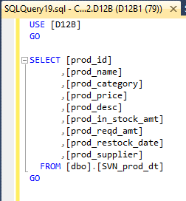

3. INSERT TO

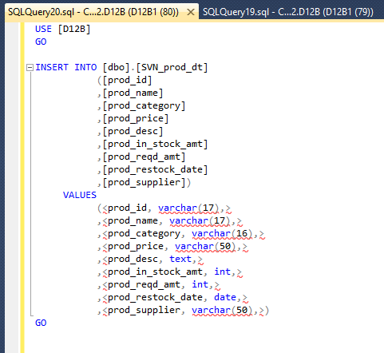

4. SELECT TOP 100 ROWS

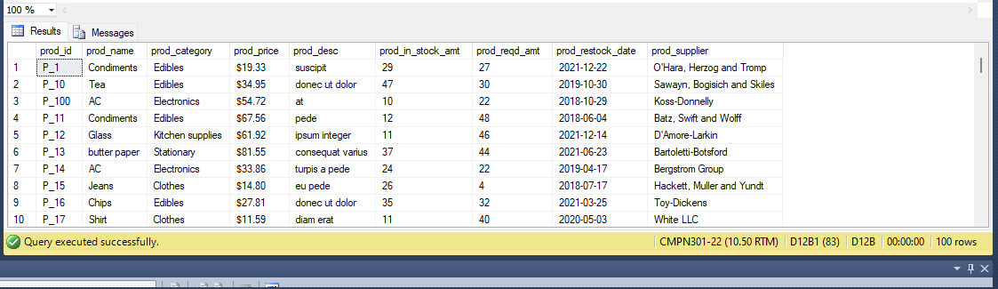

**SVN_CUST_DT**

1.CREATE TO

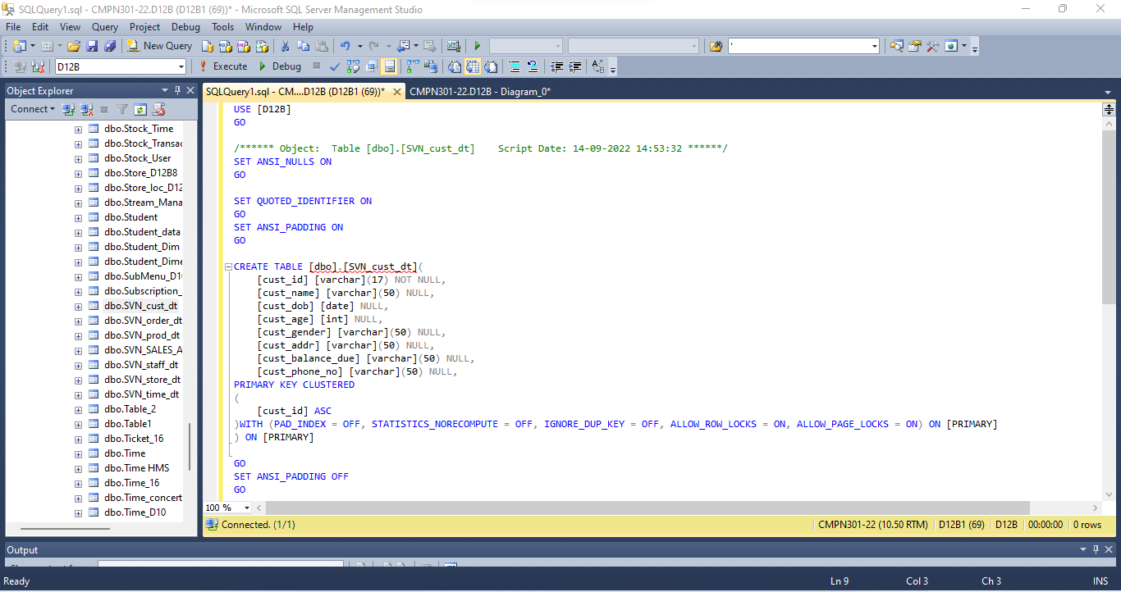

2.SELECT TO

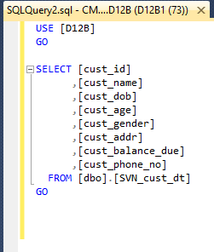

3.INSERT TO

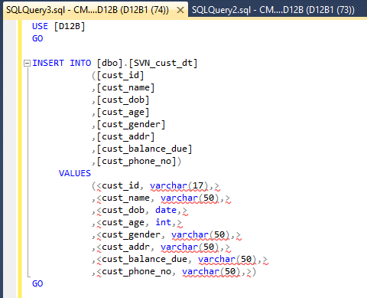

4.SELECT TOP 1000 ROWS

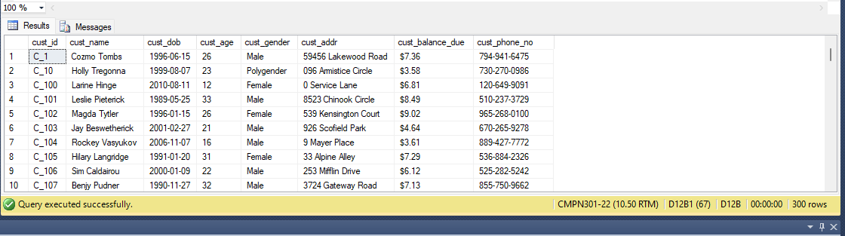

**SVN_STAFF_DT**

1.CREATE TO

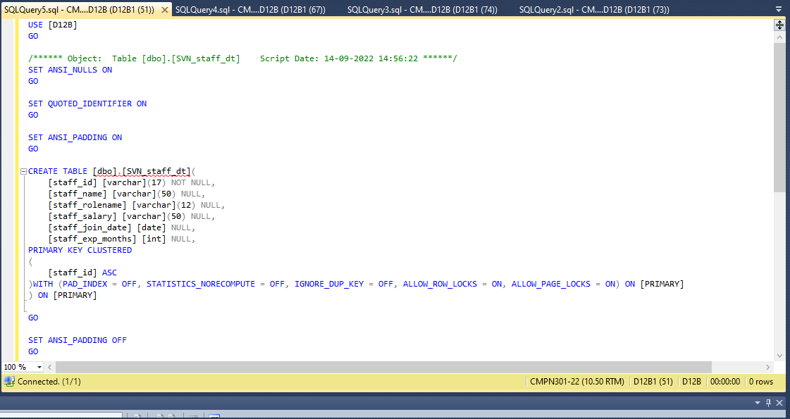

2.SELECT TO

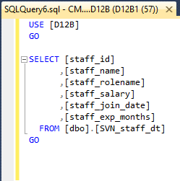

3.INSERT TO

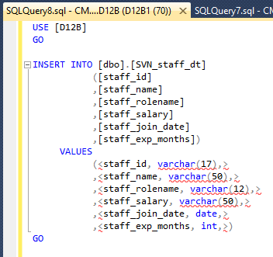

4.SELECT TOP 100 ROWS

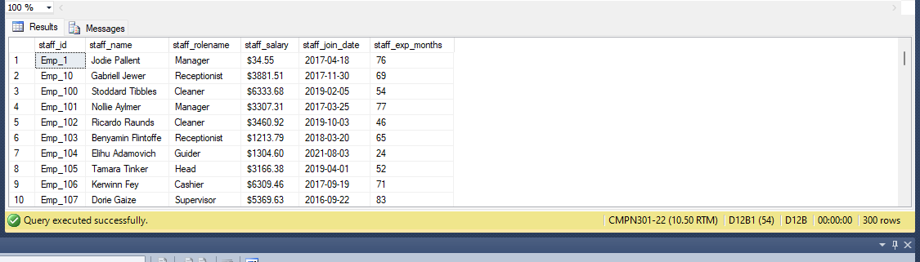

**SVN_STORE_DT**

1.CREATE TO

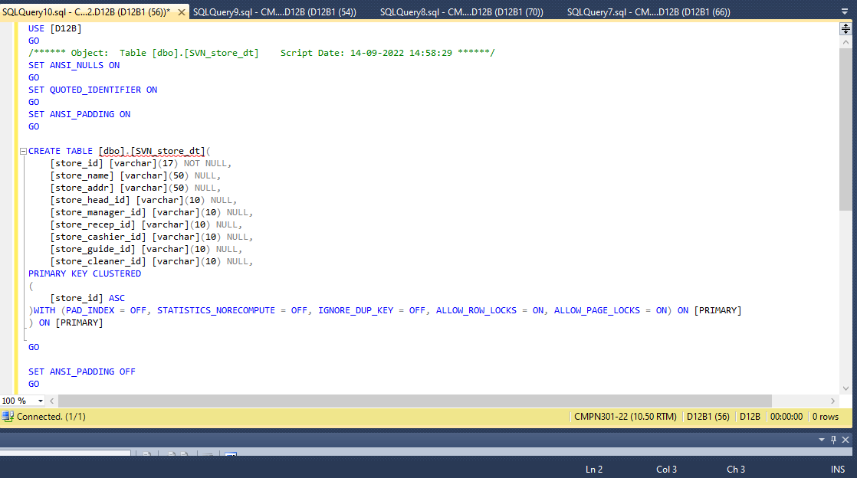

2.SELECT TO

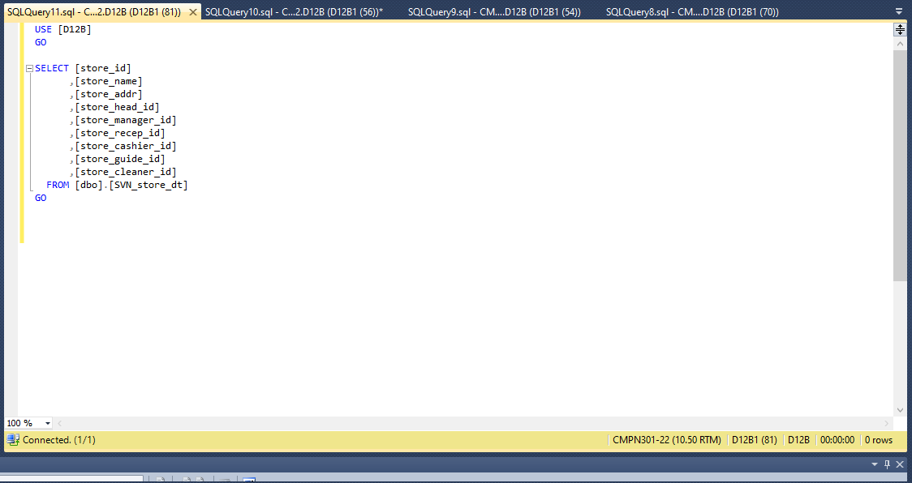

3.INSERT TO

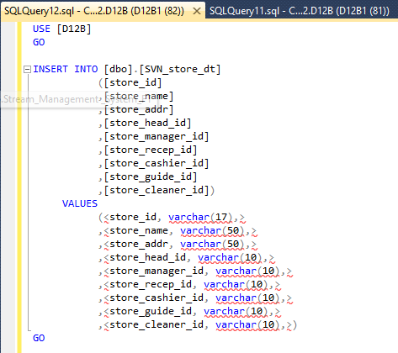

4.SELECT TOP 100 ROWS

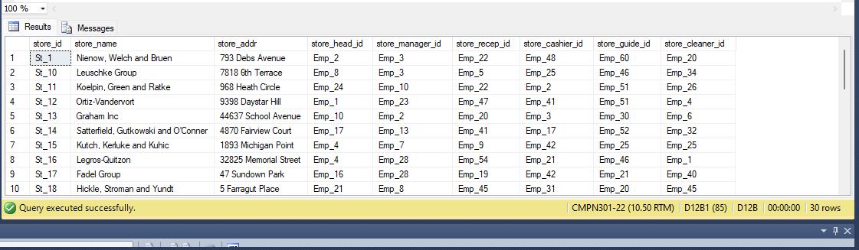

**SVN-ORDER_DT**

1.CREATE TO

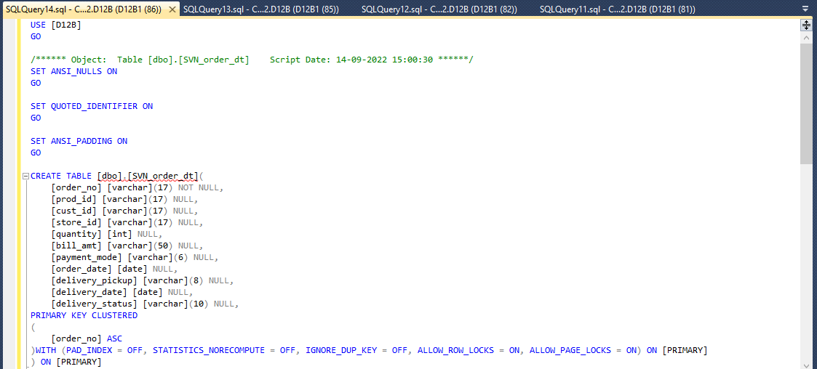

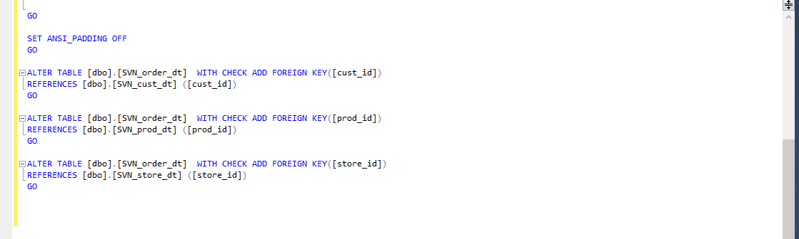

2.SELECT TO

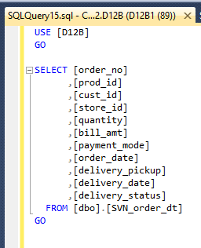

3.INSERT TO

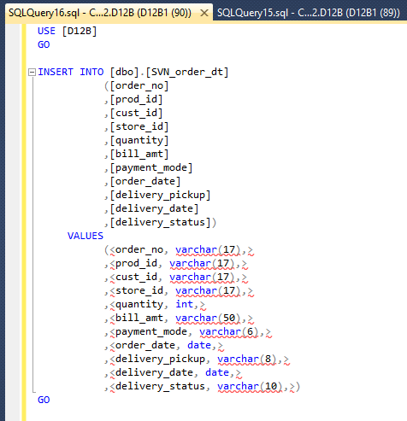

4.SELECT TOP 100 ROWS

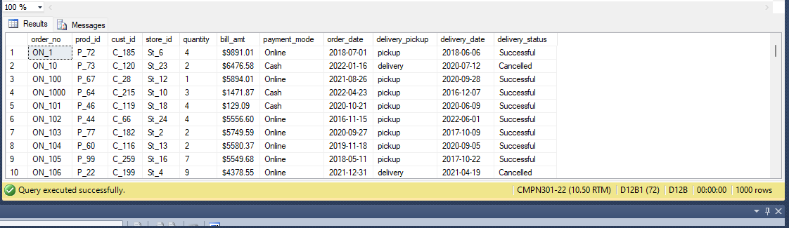

**POPULATING FACT TABLE USING PYTHON SCRIPT :**

Code :

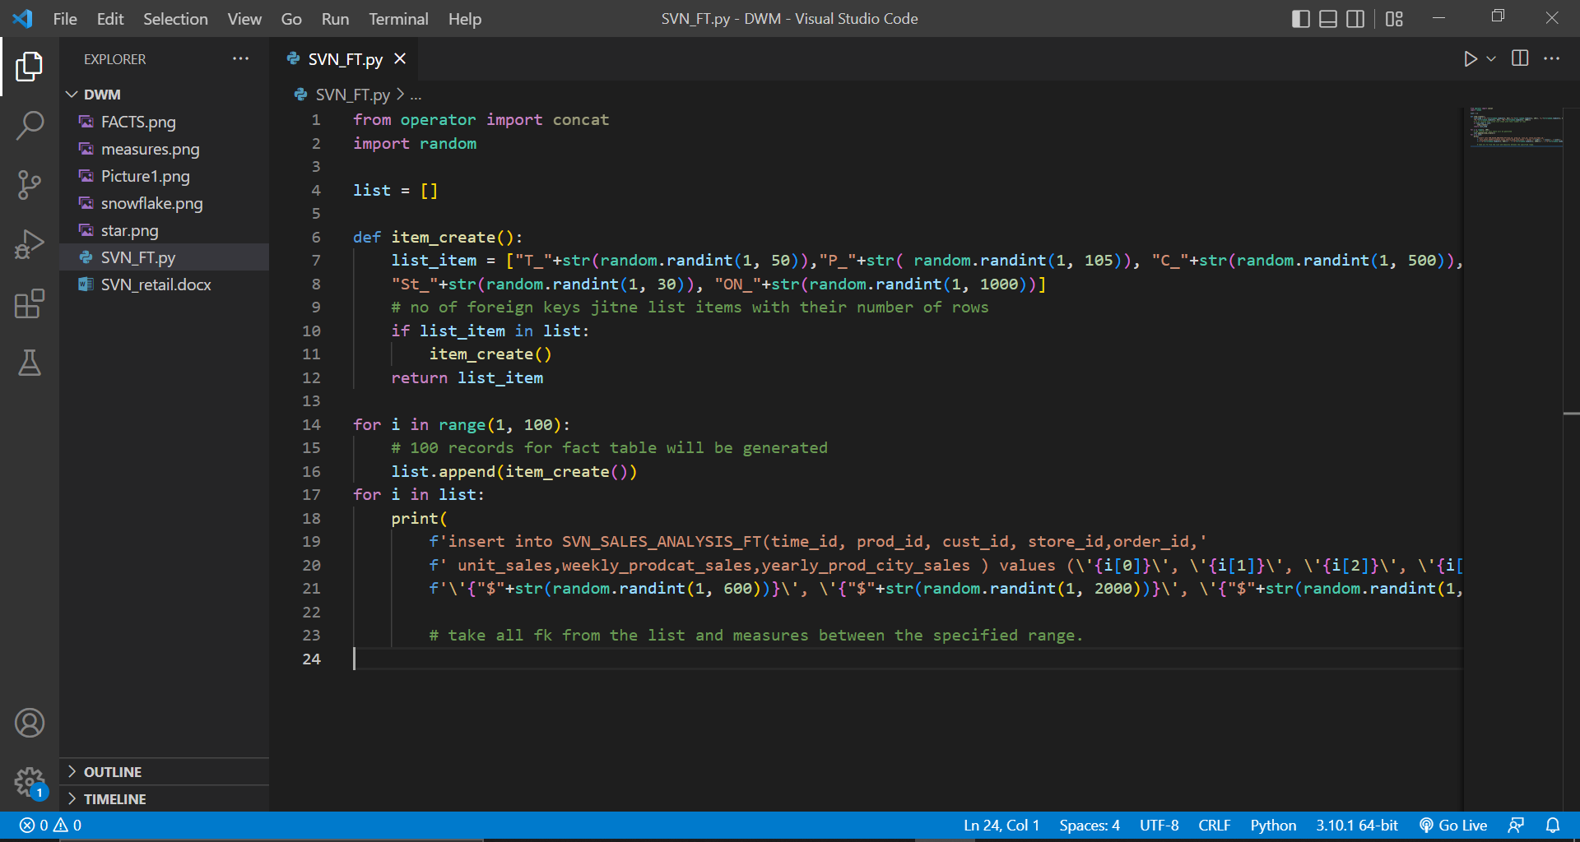

from operator import concat

import random

list = []

def item_create():

list_item = ["T_"+str(random.randint(1, 50)),"P_"+str( random.randint(1, 105)), "C_"+str(random.randint(1, 500)),

"St_"+str(random.randint(1, 30)), "ON_"+str(random.randint(1, 1000))]

# no of foreign keys jitne list items with their number of rows

if list_item in list:

item_create()

return list_item

for i in range(1, 100):

# 100 records for fact table will be generated

list.append(item_create())

for i in list:

print(

f'insert into SVN_SALES_ANALYSIS_FT(time_id, prod_id, cust_id, store_id,order_id,'

f' unit_sales,weekly_prodcat_sales,yearly_prod_city_sales ) values (\'{i[0]}\', \'{i[1]}\', \'{i[2]}\', \'{i[3]}\', \'{i[4]}\', '

f'\'{"$"+str(random.randint(1, 600))}\', \'{"$"+str(random.randint(1, 2000))}\', \'{"$"+str(random.randint(1, 10000))}\');')

# take all fk from the list and measures between the specified range.

Output :

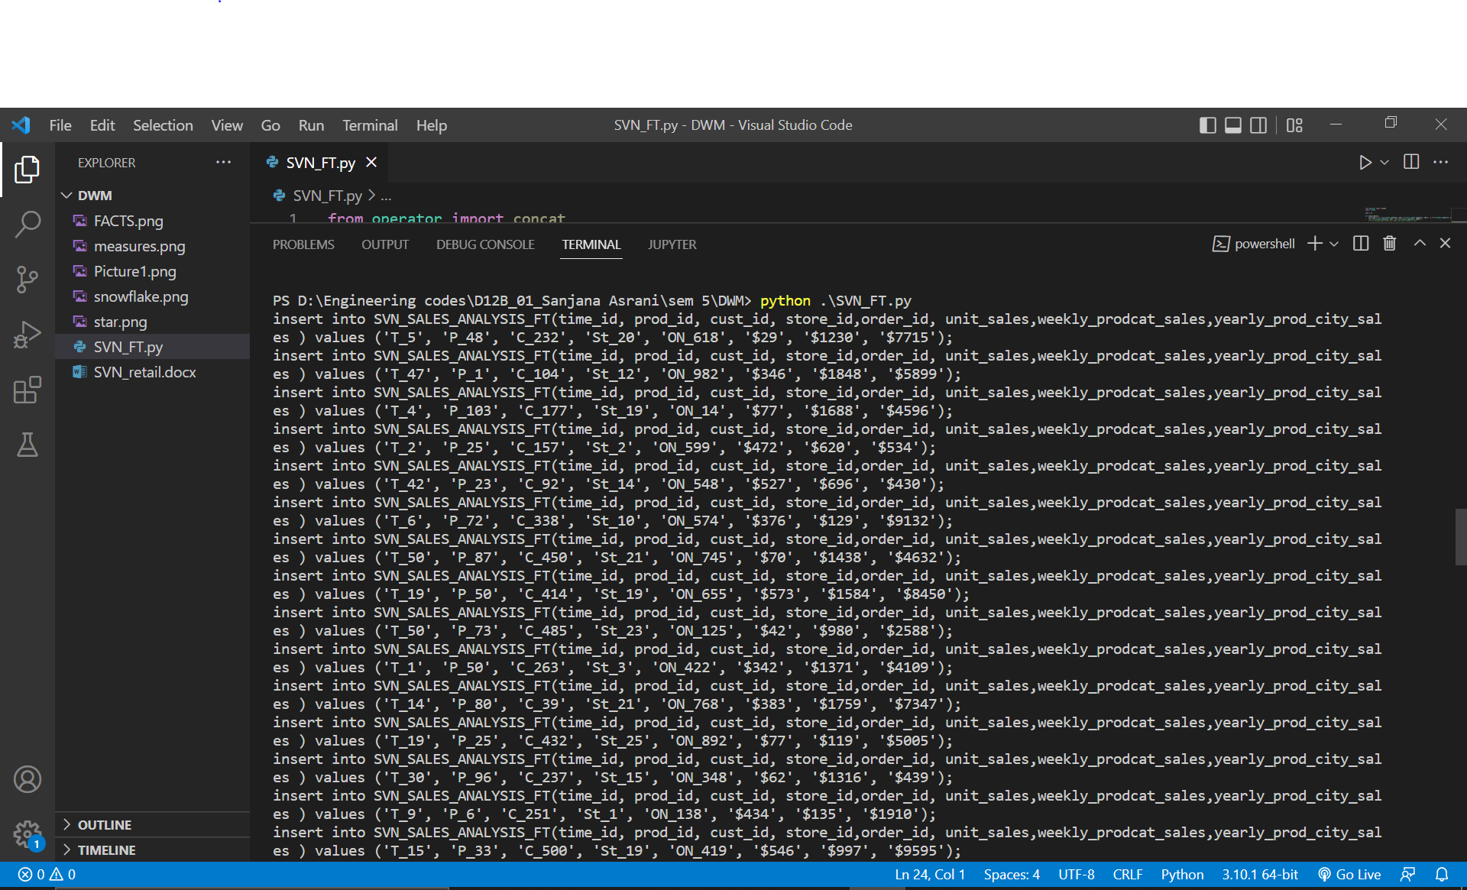

insert into SVN_SALES_ANALYSIS_FT(time_id, prod_id, cust_id, store_id,order_id, unit_sales,weekly_prodcat_sales,yearly_prod_city_sales ) values ('T_44', 'P_70', 'C_383', 'St_13', 'ON_576', '$126', '$311', '$4117');

insert into SVN_SALES_ANALYSIS_FT(time_id, prod_id, cust_id, store_id,order_id, unit_sales,weekly_prodcat_sales,yearly_prod_city_sales ) values ('T_13', 'P_42', 'C_371', 'St_21', 'ON_201', '$263', '$853', '$6470');

insert into SVN_SALES_ANALYSIS_FT(time_id, prod_id, cust_id, store_id,order_id, unit_sales,weekly_prodcat_sales,yearly_prod_city_sales ) values ('T_38', 'P_86', 'C_323', 'St_30', 'ON_932', '$130', '$1793', '$1145');

insert into SVN_SALES_ANALYSIS_FT(time_id, prod_id, cust_id, store_id,order_id, unit_sales,weekly_prodcat_sales,yearly_prod_city_sales ) values ('T_26', 'P_61', 'C_393', 'St_19', 'ON_387', '$329', '$1145', '$6070');

insert into SVN_SALES_ANALYSIS_FT(time_id, prod_id, cust_id, store_id,order_id, unit_sales,weekly_prodcat_sales,yearly_prod_city_sales ) values ('T_11', 'P_101', 'C_274', 'St_4', 'ON_564', '$483', '$989', '$1305');

insert into SVN_SALES_ANALYSIS_FT(time_id, prod_id, cust_id, store_id,order_id, unit_sales,weekly_prodcat_sales,yearly_prod_city_sales ) values ('T_32', 'P_68', 'C_56', 'St_29', 'ON_857', '$598', '$155', '$3270');

insert into SVN_SALES_ANALYSIS_FT(time_id, prod_id, cust_id, store_id,order_id, unit_sales,weekly_prodcat_sales,yearly_prod_city_sales ) values ('T_31', 'P_50', 'C_74', 'St_21', 'ON_338', '$547', '$1358', '$9562');

insert into SVN_SALES_ANALYSIS_FT(time_id, prod_id, cust_id, store_id,order_id, unit_sales,weekly_prodcat_sales,yearly_prod_city_sales ) values ('T_9', 'P_102', 'C_217', 'St_29', 'ON_562', '$349', '$1581', '$1217');

insert into SVN_SALES_ANALYSIS_FT(time_id, prod_id, cust_id, store_id,order_id, unit_sales,weekly_prodcat_sales,yearly_prod_city_sales ) values ('T_33', 'P_105', 'C_398', 'St_3', 'ON_737', '$56', '$1226', '$3292');

insert into SVN_SALES_ANALYSIS_FT(time_id, prod_id, cust_id, store_id,order_id, unit_sales,weekly_prodcat_sales,yearly_prod_city_sales ) values ('T_14', 'P_67', 'C_471', 'St_8', 'ON_603', '$138', '$954', '$7754');

insert into SVN_SALES_ANALYSIS_FT(time_id, prod_id, cust_id, store_id,order_id, unit_sales,weekly_prodcat_sales,yearly_prod_city_sales ) values ('T_30', 'P_41', 'C_442', 'St_30', 'ON_327', '$388', '$1169', '$4527');

insert into SVN_SALES_ANALYSIS_FT(time_id, prod_id, cust_id, store_id,order_id, unit_sales,weekly_prodcat_sales,yearly_prod_city_sales ) values ('T_41', 'P_89', 'C_348', 'St_28', 'ON_922', '$270', '$1233', '$617');

insert into SVN_SALES_ANALYSIS_FT(time_id, prod_id, cust_id, store_id,order_id, unit_sales,weekly_prodcat_sales,yearly_prod_city_sales ) values ('T_46', 'P_46', 'C_494', 'St_14', 'ON_87', '$340', '$1723', '$1749');

insert into SVN_SALES_ANALYSIS_FT(time_id, prod_id, cust_id, store_id,order_id, unit_sales,weekly_prodcat_sales,yearly_prod_city_sales ) values ('T_18', 'P_71', 'C_291', 'St_20', 'ON_330', '$579', '$677', '$1306');

insert into SVN_SALES_ANALYSIS_FT(time_id, prod_id, cust_id, store_id,order_id, unit_sales,weekly_prodcat_sales,yearly_prod_city_sales ) values ('T_32', 'P_9', 'C_487', 'St_30', 'ON_624', '$154', '$474', '$524');

insert into SVN_SALES_ANALYSIS_FT(time_id, prod_id, cust_id, store_id,order_id, unit_sales,weekly_prodcat_sales,yearly_prod_city_sales ) values ('T_17', 'P_29', 'C_423', 'St_4', 'ON_89', '$350', '$1551', '$6850');

insert into SVN_SALES_ANALYSIS_FT(time_id, prod_id, cust_id, store_id,order_id, unit_sales,weekly_prodcat_sales,yearly_prod_city_sales ) values ('T_49', 'P_95', 'C_109', 'St_6', 'ON_367', '$164', '$1948', '$8303');

insert into SVN_SALES_ANALYSIS_FT(time_id, prod_id, cust_id, store_id,order_id, unit_sales,weekly_prodcat_sales,yearly_prod_city_sales ) values ('T_6', 'P_17', 'C_123', 'St_8', 'ON_946', '$153', '$1616', '$3103');

insert into SVN_SALES_ANALYSIS_FT(time_id, prod_id, cust_id, store_id,order_id, unit_sales,weekly_prodcat_sales,yearly_prod_city_sales ) values ('T_4', 'P_22', 'C_214', 'St_13', 'ON_272', '$406', '$936', '$2771');

insert into SVN_SALES_ANALYSIS_FT(time_id, prod_id, cust_id, store_id,order_id, unit_sales,weekly_prodcat_sales,yearly_prod_city_sales ) values ('T_19', 'P_54', 'C_478', 'St_14', 'ON_245', '$340', '$1408', '$709');

insert into SVN_SALES_ANALYSIS_FT(time_id, prod_id, cust_id, store_id,order_id, unit_sales,weekly_prodcat_sales,yearly_prod_city_sales ) values ('T_29', 'P_53', 'C_172', 'St_29', 'ON_434', '$283', '$1636', '$2661');

insert into SVN_SALES_ANALYSIS_FT(time_id, prod_id, cust_id, store_id,order_id, unit_sales,weekly_prodcat_sales,yearly_prod_city_sales ) values ('T_36', 'P_66', 'C_385', 'St_10', 'ON_226', '$247', '$1587', '$5598');

insert into SVN_SALES_ANALYSIS_FT(time_id, prod_id, cust_id, store_id,order_id, unit_sales,weekly_prodcat_sales,yearly_prod_city_sales ) values ('T_8', 'P_19', 'C_314', 'St_14', 'ON_441', '$142', '$537', '$537');

insert into SVN_SALES_ANALYSIS_FT(time_id, prod_id, cust_id, store_id,order_id, unit_sales,weekly_prodcat_sales,yearly_prod_city_sales ) values ('T_21', 'P_70', 'C_36', 'St_11', 'ON_713', '$83', '$217', '$1772');

insert into SVN_SALES_ANALYSIS_FT(time_id, prod_id, cust_id, store_id,order_id, unit_sales,weekly_prodcat_sales,yearly_prod_city_sales ) values ('T_36', 'P_35', 'C_236', 'St_21', 'ON_957', '$290', '$878', '$22');

insert into SVN_SALES_ANALYSIS_FT(time_id, prod_id, cust_id, store_id,order_id, unit_sales,weekly_prodcat_sales,yearly_prod_city_sales ) values ('T_44', 'P_86', 'C_414', 'St_25', 'ON_665', '$173', '$189', '$6540');

insert into SVN_SALES_ANALYSIS_FT(time_id, prod_id, cust_id, store_id,order_id, unit_sales,weekly_prodcat_sales,yearly_prod_city_sales ) values ('T_40', 'P_65', 'C_343', 'St_3', 'ON_115', '$537', '$1138', '$5053');

insert into SVN_SALES_ANALYSIS_FT(time_id, prod_id, cust_id, store_id,order_id, unit_sales,weekly_prodcat_sales,yearly_prod_city_sales ) values ('T_33', 'P_105', 'C_207', 'St_20', 'ON_203', '$255', '$367', '$7701');

insert into SVN_SALES_ANALYSIS_FT(time_id, prod_id, cust_id, store_id,order_id, unit_sales,weekly_prodcat_sales,yearly_prod_city_sales ) values ('T_18', 'P_98', 'C_366', 'St_30', 'ON_406', '$198', '$1960', '$4302');

insert into SVN_SALES_ANALYSIS_FT(time_id, prod_id, cust_id, store_id,order_id, unit_sales,weekly_prodcat_sales,yearly_prod_city_sales ) values ('T_37', 'P_3', 'C_377', 'St_14', 'ON_112', '$238', '$964', '$947');

insert into SVN_SALES_ANALYSIS_FT(time_id, prod_id, cust_id, store_id,order_id, unit_sales,weekly_prodcat_sales,yearly_prod_city_sales ) values ('T_17', 'P_82', 'C_246', 'St_9', 'ON_973', '$296', '$1877', '$8293');

insert into SVN_SALES_ANALYSIS_FT(time_id, prod_id, cust_id, store_id,order_id, unit_sales,weekly_prodcat_sales,yearly_prod_city_sales ) values ('T_21', 'P_100', 'C_300', 'St_22', 'ON_902', '$387', '$252', '$8393');

insert into SVN_SALES_ANALYSIS_FT(time_id, prod_id, cust_id, store_id,order_id, unit_sales,weekly_prodcat_sales,yearly_prod_city_sales ) values ('T_43', 'P_75', 'C_18', 'St_21', 'ON_782', '$348', '$277', '$9920');

insert into SVN_SALES_ANALYSIS_FT(time_id, prod_id, cust_id, store_id,order_id, unit_sales,weekly_prodcat_sales,yearly_prod_city_sales ) values ('T_15', 'P_54', 'C_72', 'St_5', 'ON_767', '$461', '$1647', '$3100');

insert into SVN_SALES_ANALYSIS_FT(time_id, prod_id, cust_id, store_id,order_id, unit_sales,weekly_prodcat_sales,yearly_prod_city_sales ) values ('T_14', 'P_11', 'C_37', 'St_12', 'ON_686', '$174', '$440', '$3753');

insert into SVN_SALES_ANALYSIS_FT(time_id, prod_id, cust_id, store_id,order_id, unit_sales,weekly_prodcat_sales,yearly_prod_city_sales ) values ('T_21', 'P_22', 'C_407', 'St_28', 'ON_433', '$280', '$127', '$7112');

insert into SVN_SALES_ANALYSIS_FT(time_id, prod_id, cust_id, store_id,order_id, unit_sales,weekly_prodcat_sales,yearly_prod_city_sales ) values ('T_30', 'P_103', 'C_323', 'St_7', 'ON_469', '$335', '$1400', '$9780');

insert into SVN_SALES_ANALYSIS_FT(time_id, prod_id, cust_id, store_id,order_id, unit_sales,weekly_prodcat_sales,yearly_prod_city_sales ) values ('T_39', 'P_60', 'C_162', 'St_19', 'ON_108', '$378', '$993', '$3329');

insert into SVN_SALES_ANALYSIS_FT(time_id, prod_id, cust_id, store_id,order_id, unit_sales,weekly_prodcat_sales,yearly_prod_city_sales ) values ('T_7', 'P_72', 'C_247', 'St_11', 'ON_676', '$491', '$306', '$3548');

insert into SVN_SALES_ANALYSIS_FT(time_id, prod_id, cust_id, store_id,order_id, unit_sales,weekly_prodcat_sales,yearly_prod_city_sales ) values ('T_38', 'P_87', 'C_448', 'St_12', 'ON_426', '$502', '$272', '$9945');

insert into SVN_SALES_ANALYSIS_FT(time_id, prod_id, cust_id, store_id,order_id, unit_sales,weekly_prodcat_sales,yearly_prod_city_sales ) values ('T_37', 'P_76', 'C_14', 'St_30', 'ON_93', '$519', '$1361', '$8225');

insert into SVN_SALES_ANALYSIS_FT(time_id, prod_id, cust_id, store_id,order_id, unit_sales,weekly_prodcat_sales,yearly_prod_city_sales ) values ('T_9', 'P_9', 'C_51', 'St_7', 'ON_124', '$538', '$1660', '$4623');

insert into SVN_SALES_ANALYSIS_FT(time_id, prod_id, cust_id, store_id,order_id, unit_sales,weekly_prodcat_sales,yearly_prod_city_sales ) values ('T_31', 'P_63', 'C_23', 'St_10', 'ON_108', '$414', '$161', '$9413');

insert into SVN_SALES_ANALYSIS_FT(time_id, prod_id, cust_id, store_id,order_id, unit_sales,weekly_prodcat_sales,yearly_prod_city_sales ) values ('T_23', 'P_59', 'C_307', 'St_10', 'ON_670', '$43', '$1043', '$4600');

insert into SVN_SALES_ANALYSIS_FT(time_id, prod_id, cust_id, store_id,order_id, unit_sales,weekly_prodcat_sales,yearly_prod_city_sales ) values ('T_48', 'P_16', 'C_190', 'St_2', 'ON_389', '$599', '$1277', '$2493');

insert into SVN_SALES_ANALYSIS_FT(time_id, prod_id, cust_id, store_id,order_id, unit_sales,weekly_prodcat_sales,yearly_prod_city_sales ) values ('T_32', 'P_40', 'C_293', 'St_2', 'ON_914', '$353', '$603', '$9944');

insert into SVN_SALES_ANALYSIS_FT(time_id, prod_id, cust_id, store_id,order_id, unit_sales,weekly_prodcat_sales,yearly_prod_city_sales ) values ('T_44', 'P_86', 'C_100', 'St_4', 'ON_35', '$509', '$1743', '$6509');

insert into SVN_SALES_ANALYSIS_FT(time_id, prod_id, cust_id, store_id,order_id, unit_sales,weekly_prodcat_sales,yearly_prod_city_sales ) values ('T_18', 'P_61', 'C_296', 'St_5', 'ON_63', '$504', '$1713', '$3096');

insert into SVN_SALES_ANALYSIS_FT(time_id, prod_id, cust_id, store_id,order_id, unit_sales,weekly_prodcat_sales,yearly_prod_city_sales ) values ('T_20', 'P_100', 'C_28', 'St_6', 'ON_726', '$162', '$513', '$4739');

insert into SVN_SALES_ANALYSIS_FT(time_id, prod_id, cust_id, store_id,order_id, unit_sales,weekly_prodcat_sales,yearly_prod_city_sales ) values ('T_13', 'P_8', 'C_10', 'St_26', 'ON_116', '$427', '$976', '$1135');

insert into SVN_SALES_ANALYSIS_FT(time_id, prod_id, cust_id, store_id,order_id, unit_sales,weekly_prodcat_sales,yearly_prod_city_sales ) values ('T_25', 'P_39', 'C_231', 'St_13', 'ON_642', '$68', '$1750', '$4676');

insert into SVN_SALES_ANALYSIS_FT(time_id, prod_id, cust_id, store_id,order_id, unit_sales,weekly_prodcat_sales,yearly_prod_city_sales ) values ('T_7', 'P_47', 'C_9', 'St_5', 'ON_529', '$555', '$1029', '$788');

insert into SVN_SALES_ANALYSIS_FT(time_id, prod_id, cust_id, store_id,order_id, unit_sales,weekly_prodcat_sales,yearly_prod_city_sales ) values ('T_1', 'P_95', 'C_227', 'St_4', 'ON_873', '$422', '$1722', '$199');

insert into SVN_SALES_ANALYSIS_FT(time_id, prod_id, cust_id, store_id,order_id, unit_sales,weekly_prodcat_sales,yearly_prod_city_sales ) values ('T_6', 'P_3', 'C_263', 'St_30', 'ON_804', '$484', '$1550', '$3275');

insert into SVN_SALES_ANALYSIS_FT(time_id, prod_id, cust_id, store_id,order_id, unit_sales,weekly_prodcat_sales,yearly_prod_city_sales ) values ('T_23', 'P_64', 'C_48', 'St_3', 'ON_830', '$293', '$1931', '$9442');

insert into SVN_SALES_ANALYSIS_FT(time_id, prod_id, cust_id, store_id,order_id, unit_sales,weekly_prodcat_sales,yearly_prod_city_sales ) values ('T_7', 'P_46', 'C_288', 'St_14', 'ON_848', '$496', '$1402', '$5618');

insert into SVN_SALES_ANALYSIS_FT(time_id, prod_id, cust_id, store_id,order_id, unit_sales,weekly_prodcat_sales,yearly_prod_city_sales ) values ('T_3', 'P_53', 'C_125', 'St_22', 'ON_234', '$22', '$1354', '$5007');

insert into SVN_SALES_ANALYSIS_FT(time_id, prod_id, cust_id, store_id,order_id, unit_sales,weekly_prodcat_sales,yearly_prod_city_sales ) values ('T_15', 'P_45', 'C_74', 'St_12', 'ON_131', '$81', '$307', '$4909');

insert into SVN_SALES_ANALYSIS_FT(time_id, prod_id, cust_id, store_id,order_id, unit_sales,weekly_prodcat_sales,yearly_prod_city_sales ) values ('T_25', 'P_15', 'C_271', 'St_18', 'ON_3', '$270', '$349', '$5221');

insert into SVN_SALES_ANALYSIS_FT(time_id, prod_id, cust_id, store_id,order_id, unit_sales,weekly_prodcat_sales,yearly_prod_city_sales ) values ('T_37', 'P_44', 'C_1', 'St_10', 'ON_620', '$342', '$625', '$4157');

insert into SVN_SALES_ANALYSIS_FT(time_id, prod_id, cust_id, store_id,order_id, unit_sales,weekly_prodcat_sales,yearly_prod_city_sales ) values ('T_10', 'P_97', 'C_482', 'St_11', 'ON_810', '$490', '$432', '$7328');

insert into SVN_SALES_ANALYSIS_FT(time_id, prod_id, cust_id, store_id,order_id, unit_sales,weekly_prodcat_sales,yearly_prod_city_sales ) values ('T_2', 'P_42', 'C_187', 'St_14', 'ON_317', '$490', '$745', '$317');

insert into SVN_SALES_ANALYSIS_FT(time_id, prod_id, cust_id, store_id,order_id, unit_sales,weekly_prodcat_sales,yearly_prod_city_sales ) values ('T_3', 'P_55', 'C_13', 'St_26', 'ON_865', '$561', '$454', '$9814');

insert into SVN_SALES_ANALYSIS_FT(time_id, prod_id, cust_id, store_id,order_id, unit_sales,weekly_prodcat_sales,yearly_prod_city_sales ) values ('T_43', 'P_54', 'C_37', 'St_29', 'ON_526', '$230', '$32', '$4713');

insert into SVN_SALES_ANALYSIS_FT(time_id, prod_id, cust_id, store_id,order_id, unit_sales,weekly_prodcat_sales,yearly_prod_city_sales ) values ('T_50', 'P_53', 'C_75', 'St_14', 'ON_362', '$356', '$178', '$8159');

insert into SVN_SALES_ANALYSIS_FT(time_id, prod_id, cust_id, store_id,order_id, unit_sales,weekly_prodcat_sales,yearly_prod_city_sales ) values ('T_32', 'P_72', 'C_393', 'St_23', 'ON_124', '$206', '$1848', '$5017');

insert into SVN_SALES_ANALYSIS_FT(time_id, prod_id, cust_id, store_id,order_id, unit_sales,weekly_prodcat_sales,yearly_prod_city_sales ) values ('T_50', 'P_18', 'C_228', 'St_3', 'ON_602', '$214', '$554', '$9503');

insert into SVN_SALES_ANALYSIS_FT(time_id, prod_id, cust_id, store_id,order_id, unit_sales,weekly_prodcat_sales,yearly_prod_city_sales ) values ('T_11', 'P_67', 'C_331', 'St_11', 'ON_404', '$246', '$1473', '$4740');

insert into SVN_SALES_ANALYSIS_FT(time_id, prod_id, cust_id, store_id,order_id, unit_sales,weekly_prodcat_sales,yearly_prod_city_sales ) values ('T_25', 'P_7', 'C_378', 'St_3', 'ON_317', '$525', '$1976', '$799');

insert into SVN_SALES_ANALYSIS_FT(time_id, prod_id, cust_id, store_id,order_id, unit_sales,weekly_prodcat_sales,yearly_prod_city_sales ) values ('T_22', 'P_38', 'C_176', 'St_29', 'ON_562', '$148', '$1675', '$5363');

insert into SVN_SALES_ANALYSIS_FT(time_id, prod_id, cust_id, store_id,order_id, unit_sales,weekly_prodcat_sales,yearly_prod_city_sales ) values ('T_22', 'P_102', 'C_453', 'St_4', 'ON_506', '$374', '$1759', '$7482');

insert into SVN_SALES_ANALYSIS_FT(time_id, prod_id, cust_id, store_id,order_id, unit_sales,weekly_prodcat_sales,yearly_prod_city_sales ) values ('T_40', 'P_96', 'C_303', 'St_24', 'ON_650', '$436', '$1410', '$8239');

insert into SVN_SALES_ANALYSIS_FT(time_id, prod_id, cust_id, store_id,order_id, unit_sales,weekly_prodcat_sales,yearly_prod_city_sales ) values ('T_19', 'P_103', 'C_310', 'St_2', 'ON_452', '$570', '$1726', '$3752');

insert into SVN_SALES_ANALYSIS_FT(time_id, prod_id, cust_id, store_id,order_id, unit_sales,weekly_prodcat_sales,yearly_prod_city_sales ) values ('T_46', 'P_82', 'C_207', 'St_26', 'ON_485', '$292', '$1449', '$9955');

insert into SVN_SALES_ANALYSIS_FT(time_id, prod_id, cust_id, store_id,order_id, unit_sales,weekly_prodcat_sales,yearly_prod_city_sales ) values ('T_6', 'P_4', 'C_277', 'St_26', 'ON_204', '$288', '$497', '$700');

insert into SVN_SALES_ANALYSIS_FT(time_id, prod_id, cust_id, store_id,order_id, unit_sales,weekly_prodcat_sales,yearly_prod_city_sales ) values ('T_37', 'P_26', 'C_368', 'St_14', 'ON_726', '$271', '$1837', '$7215');

insert into SVN_SALES_ANALYSIS_FT(time_id, prod_id, cust_id, store_id,order_id, unit_sales,weekly_prodcat_sales,yearly_prod_city_sales ) values ('T_44', 'P_99', 'C_238', 'St_1', 'ON_723', '$293', '$1569', '$1591');

insert into SVN_SALES_ANALYSIS_FT(time_id, prod_id, cust_id, store_id,order_id, unit_sales,weekly_prodcat_sales,yearly_prod_city_sales ) values ('T_26', 'P_78', 'C_70', 'St_23', 'ON_441', '$237', '$1753', '$6485');

insert into SVN_SALES_ANALYSIS_FT(time_id, prod_id, cust_id, store_id,order_id, unit_sales,weekly_prodcat_sales,yearly_prod_city_sales ) values ('T_16', 'P_1', 'C_203', 'St_22', 'ON_28', '$353', '$245', '$5195');

insert into SVN_SALES_ANALYSIS_FT(time_id, prod_id, cust_id, store_id,order_id, unit_sales,weekly_prodcat_sales,yearly_prod_city_sales ) values ('T_48', 'P_81', 'C_38', 'St_14', 'ON_71', '$2', '$1577', '$6971');

insert into SVN_SALES_ANALYSIS_FT(time_id, prod_id, cust_id, store_id,order_id, unit_sales,weekly_prodcat_sales,yearly_prod_city_sales ) values ('T_12', 'P_15', 'C_46', 'St_28', 'ON_805', '$412', '$1630', '$7997');

insert into SVN_SALES_ANALYSIS_FT(time_id, prod_id, cust_id, store_id,order_id, unit_sales,weekly_prodcat_sales,yearly_prod_city_sales ) values ('T_19', 'P_56', 'C_4', 'St_5', 'ON_790', '$422', '$703', '$3604');

insert into SVN_SALES_ANALYSIS_FT(time_id, prod_id, cust_id, store_id,order_id, unit_sales,weekly_prodcat_sales,yearly_prod_city_sales ) values ('T_9', 'P_32', 'C_412', 'St_7', 'ON_688', '$299', '$787', '$6782');

insert into SVN_SALES_ANALYSIS_FT(time_id, prod_id, cust_id, store_id,order_id, unit_sales,weekly_prodcat_sales,yearly_prod_city_sales ) values ('T_37', 'P_97', 'C_66', 'St_10', 'ON_653', '$316', '$1155', '$215');

insert into SVN_SALES_ANALYSIS_FT(time_id, prod_id, cust_id, store_id,order_id, unit_sales,weekly_prodcat_sales,yearly_prod_city_sales ) values ('T_1', 'P_4', 'C_462', 'St_19', 'ON_495', '$172', '$140', '$9313');

insert into SVN_SALES_ANALYSIS_FT(time_id, prod_id, cust_id, store_id,order_id, unit_sales,weekly_prodcat_sales,yearly_prod_city_sales ) values ('T_46', 'P_3', 'C_91', 'St_29', 'ON_192', '$143', '$34', '$8775');

insert into SVN_SALES_ANALYSIS_FT(time_id, prod_id, cust_id, store_id,order_id, unit_sales,weekly_prodcat_sales,yearly_prod_city_sales ) values ('T_16', 'P_73', 'C_373', 'St_30', 'ON_780', '$21', '$895', '$21');

insert into SVN_SALES_ANALYSIS_FT(time_id, prod_id, cust_id, store_id,order_id, unit_sales,weekly_prodcat_sales,yearly_prod_city_sales ) values ('T_36', 'P_45', 'C_498', 'St_2', 'ON_580', '$43', '$733', '$380');

insert into SVN_SALES_ANALYSIS_FT(time_id, prod_id, cust_id, store_id,order_id, unit_sales,weekly_prodcat_sales,yearly_prod_city_sales ) values ('T_25', 'P_73', 'C_127', 'St_15', 'ON_853', '$434', '$443', '$7936');

insert into SVN_SALES_ANALYSIS_FT(time_id, prod_id, cust_id, store_id,order_id, unit_sales,weekly_prodcat_sales,yearly_prod_city_sales ) values ('T_26', 'P_72', 'C_195', 'St_5', 'ON_876', '$198', '$49', '$7410');

insert into SVN_SALES_ANALYSIS_FT(time_id, prod_id, cust_id, store_id,order_id, unit_sales,weekly_prodcat_sales,yearly_prod_city_sales ) values ('T_19', 'P_52', 'C_250', 'St_23', 'ON_499', '$157', '$1666', '$6073');

insert into SVN_SALES_ANALYSIS_FT(time_id, prod_id, cust_id, store_id,order_id, unit_sales,weekly_prodcat_sales,yearly_prod_city_sales ) values ('T_39', 'P_50', 'C_303', 'St_6', 'ON_453', '$23', '$564', '$8747');

insert into SVN_SALES_ANALYSIS_FT(time_id, prod_id, cust_id, store_id,order_id, unit_sales,weekly_prodcat_sales,yearly_prod_city_sales ) values ('T_50', 'P_51', 'C_413', 'St_7', 'ON_555', '$316', '$373', '$3717');

insert into SVN_SALES_ANALYSIS_FT(time_id, prod_id, cust_id, store_id,order_id, unit_sales,weekly_prodcat_sales,yearly_prod_city_sales ) values ('T_39', 'P_77', 'C_297', 'St_22', 'ON_708', '$493', '$697', '$8161');

insert into SVN_SALES_ANALYSIS_FT(time_id, prod_id, cust_id, store_id,order_id, unit_sales,weekly_prodcat_sales,yearly_prod_city_sales ) values ('T_17', 'P_84', 'C_278', 'St_15', 'ON_151', '$399', '$1102', '$2080');

insert into SVN_SALES_ANALYSIS_FT(time_id, prod_id, cust_id, store_id,order_id, unit_sales,weekly_prodcat_sales,yearly_prod_city_sales ) values ('T_25', 'P_6', 'C_86', 'St_5', 'ON_949', '$127', '$487', '$7023');

insert into SVN_SALES_ANALYSIS_FT(time_id, prod_id, cust_id, store_id,order_id, unit_sales,weekly_prodcat_sales,yearly_prod_city_sales ) values ('T_49', 'P_41', 'C_59', 'St_29', 'ON_268', '$191', '$1393', '$1786');

insert into SVN_SALES_ANALYSIS_FT(time_id, prod_id, cust_id, store_id,order_id, unit_sales,weekly_prodcat_sales,yearly_prod_city_sales ) values ('T_4', 'P_27', 'C_433', 'St_26', 'ON_949', '$326', '$294', '$776');

insert into SVN_SALES_ANALYSIS_FT(time_id, prod_id, cust_id, store_id,order_id, unit_sales,weekly_prodcat_sales,yearly_prod_city_sales ) values ('T_32', 'P_67', 'C_213', 'St_7', 'ON_769', '$439', '$1898', '$7125');

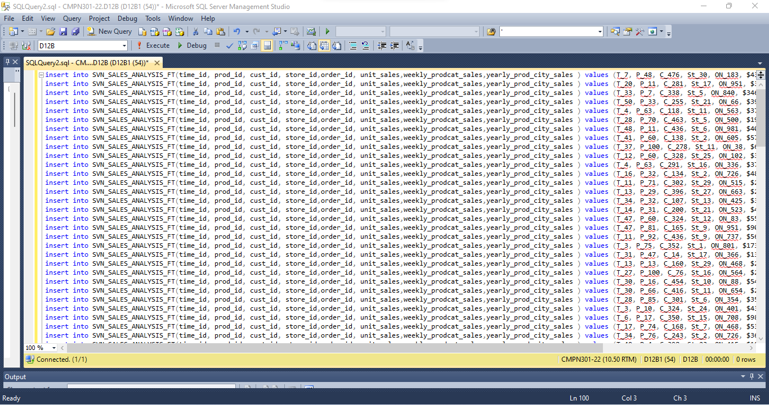

Executing above insert queries on a new query window in SQL manager :

Successfully inserted :

( click on file -> new -> database engine query)

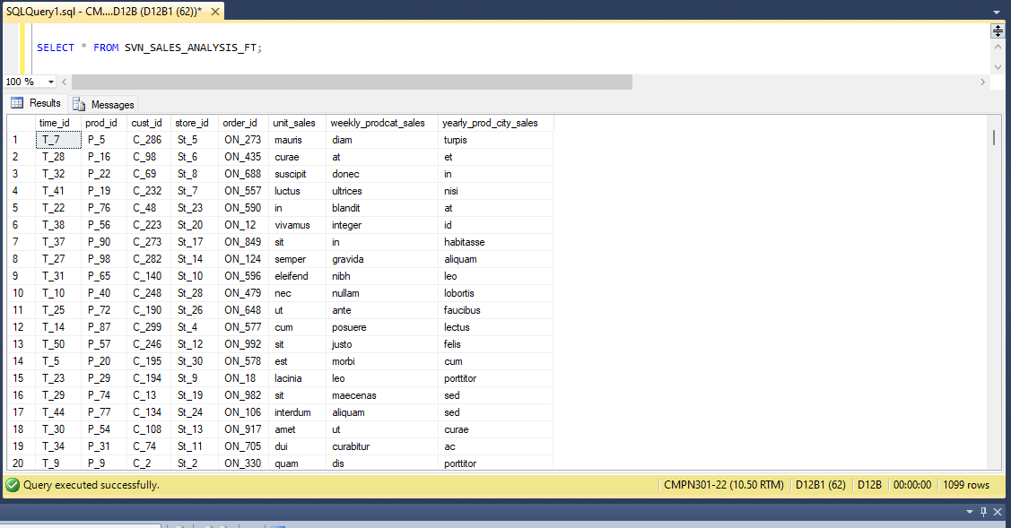

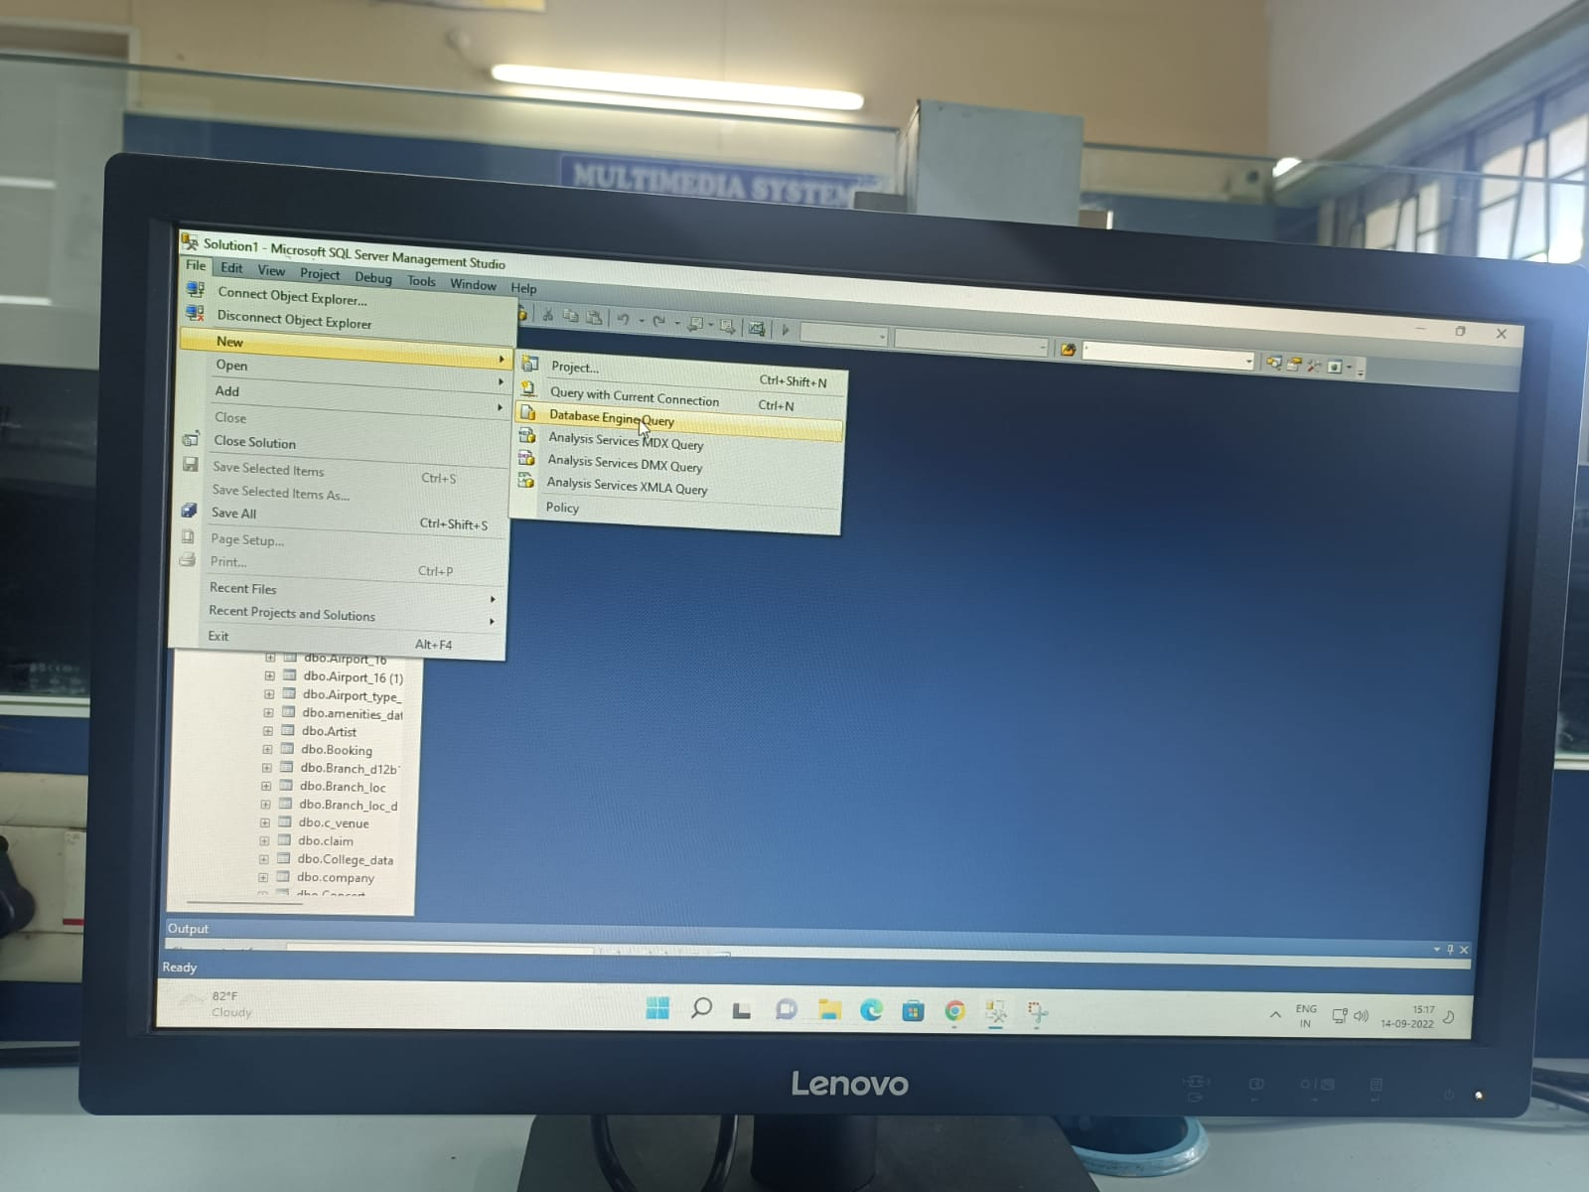

Select * from SVN_PRODUCT_DT;

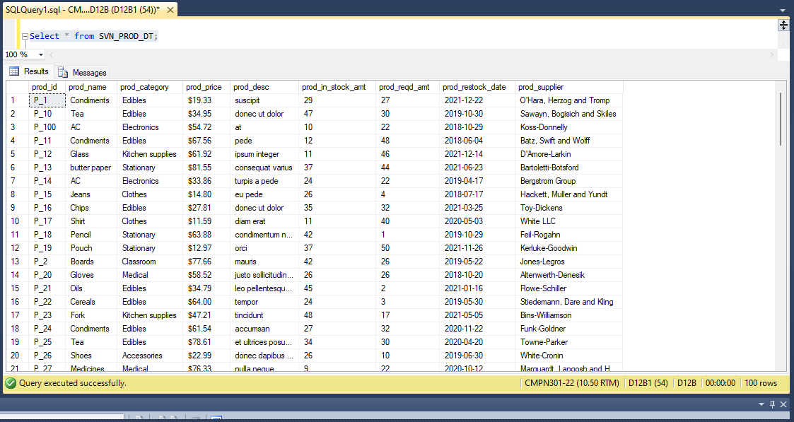

Select * from SVN_CUST_DT;

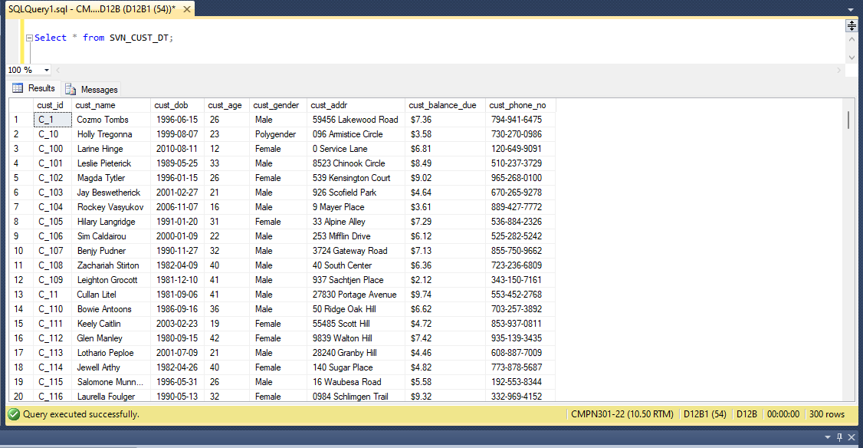

Select * from SVN_STAFF_DT;

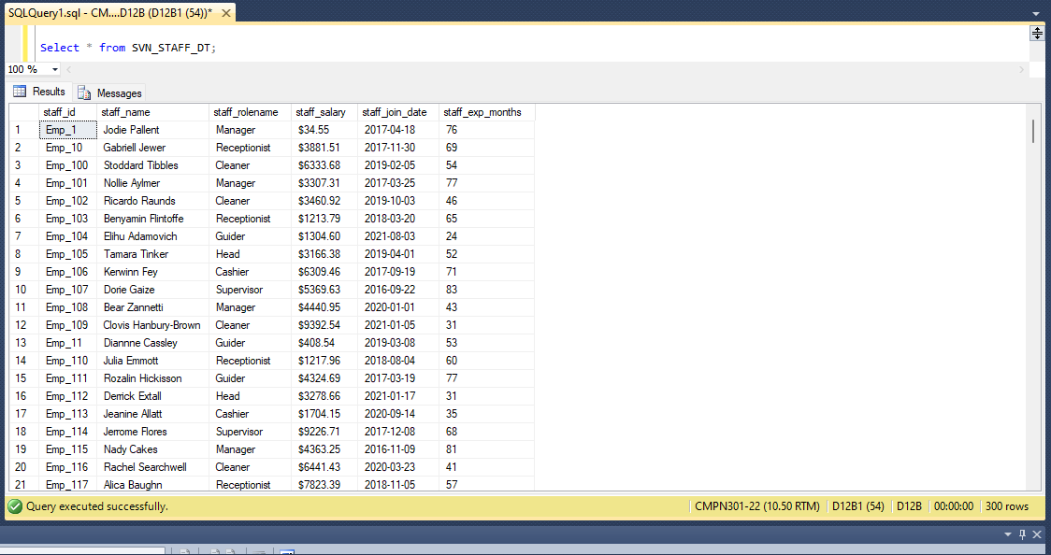

Select * from SVN_STORE_DT;

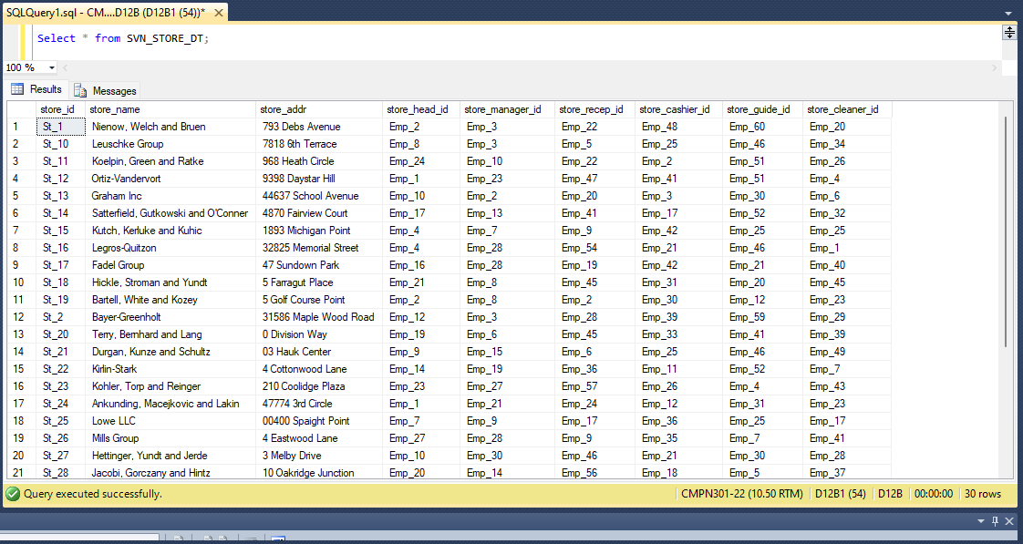

Select * from SVN_ORDER_DT;

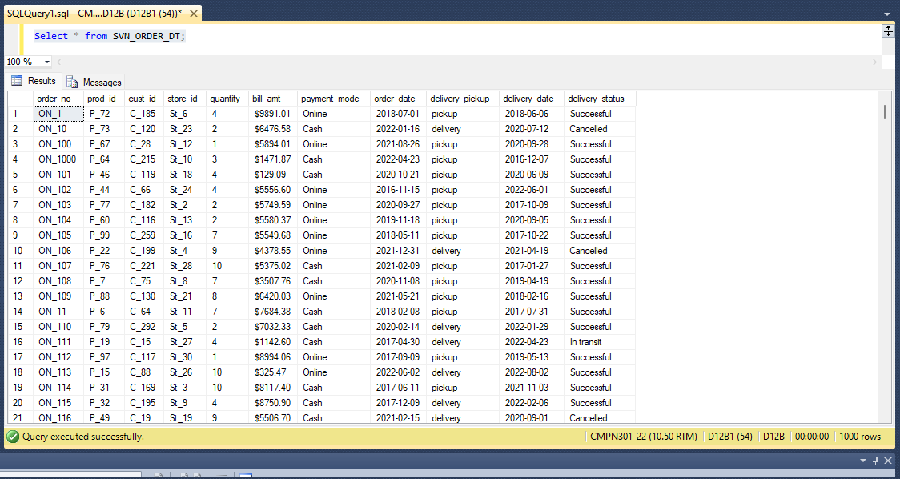

Select * from SVN_SALES_ANAPYSIS_FT;

SVN_SALES_ANALYSIS_FT

CREATE TO

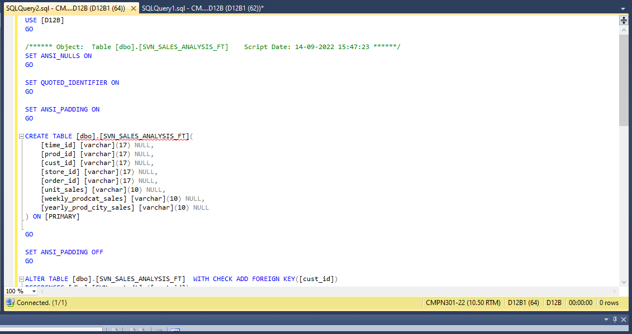

SELECT TO

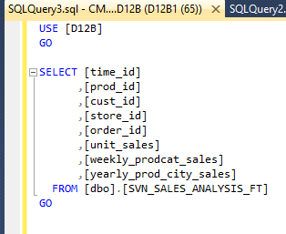

INSERT TO



INSERT TO

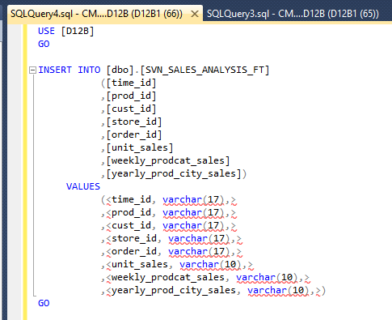

SELECT TOP 1000 ROWS

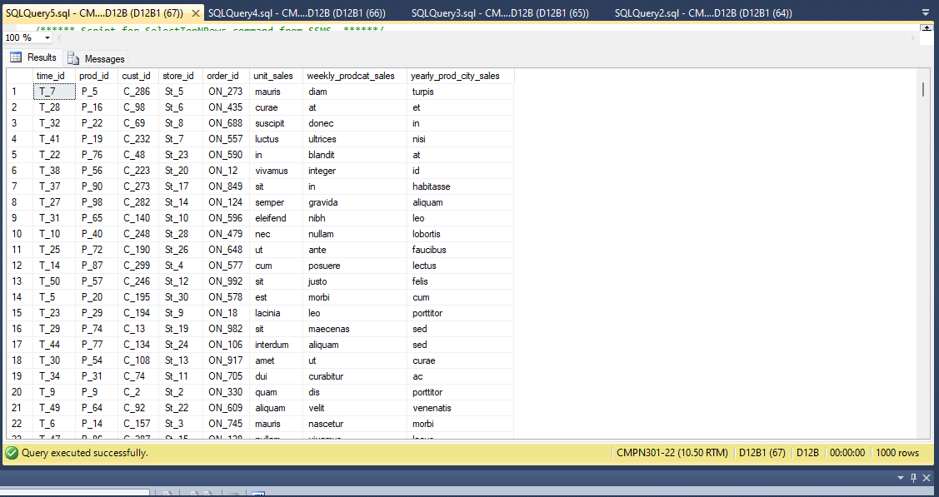

Slice

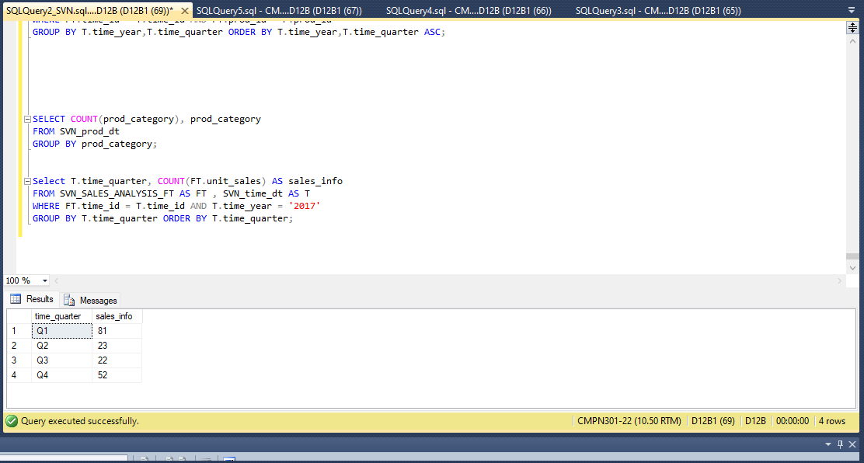

SELECT COUNT(prod_category), prod_category

FROM SVN_prod_dt

GROUP BY prod_category;

Select T.time_quarter, COUNT(FT.unit_sales) AS sales_info

FROM SVN_SALES_ANALYSIS_FT AS FT , SVN_time_dt AS T

WHERE FT.time_id = T.time_id AND T.time_year = '2017'

GROUP BY T.time_quarter ORDER BY T.time_quarter;

Dice :

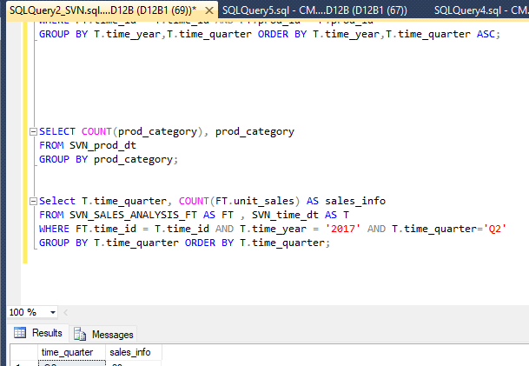

Select T.time_quarter, COUNT(FT.unit_sales) AS sales_info

FROM SVN_SALES_ANALYSIS_FT AS FT , SVN_time_dt AS T

WHERE FT.time_id = T.time_id AND T.time_year = '2017' AND T.time_quarter='Q2'

GROUP BY T.time_quarter ORDER BY T.time_quarter;

………………………………………………………………………………………………………………………………………………………………………………

SELECT prod_category , COUNT(prod_id) as No_of_products

FROM SVN_prod_dt

GROUP BY prod_category;

// ek category mei kitne prods hai

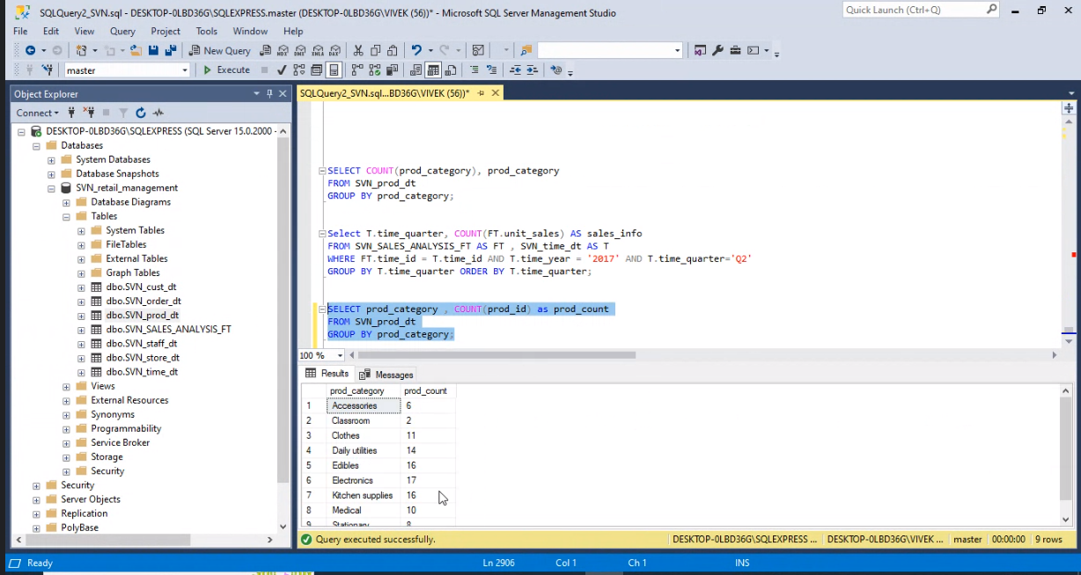

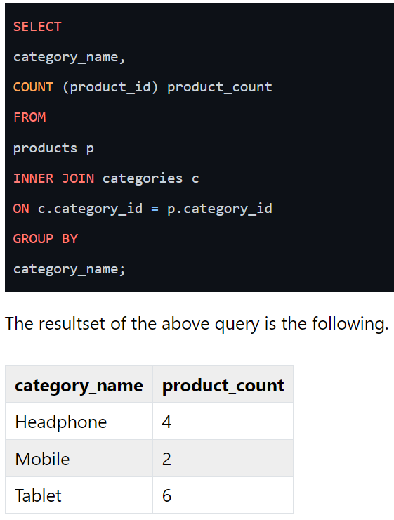

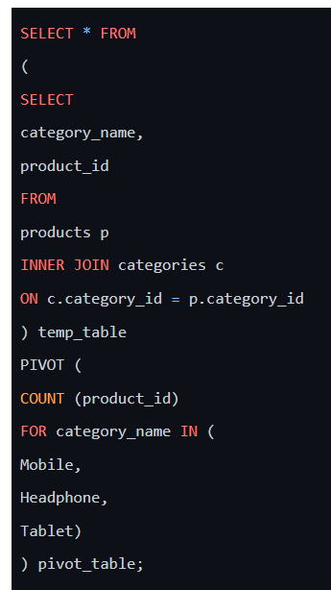

SELECT * FROM

(

SELECT prod_category, prod_id, COUNT(prod_id) FROM SVN_prod_dt)

temp_table

PIVOT (

COUNT (prod_id) FOR prod_category IN

(Stationary, Electronics, Clothes, Accessories, Edibles, Medical, Classroom, Daily utilities, Kitchen supplies)

)

Pivot_table;



